## Before you begin

### 1. Start up the porometer

1. Check the chamber to see if it is clean. If dirty, clean with distilled water and/or isopropyl alcohol following manufacturer’s cleaning instructions
2. Start the Porometer by pressing the circular button
   * Check the battery. It should be able to measure 500-800 individuals on a full charge
   * Plug into battery pack, if using
3. Match
   * The chamber should be empty (no leaf) and closed.
   * Go to “setting” (right button) - “Match”. It will take about 30s.
     + Porometer will auto-match during measurements every 15-20 min.

### 2. Start a new file

* After the match, go “home” (right button) choose the "*persist-gsw*" and select by pressing the circular button

## Measurements

### 1. Choose a leaf

These are rules-of-thumb and you might need to make some adjustments for certain plants. Ask Dr. Muir about exceptions and make a note of them in the datasheet.

For early season

* Upper-most, full-expanded leaf on main stem
* Unshaded - if an area is shaded, come back at a different time of day
* Healthy - no or minimal signs of disease or yellowing
* Undamaged - no signs of mechanical damage or herbivory
  + If every appropriate leaf has some herbivory, use the least-damaged leaf
* The leaf surface should be **dry** and mostly clear of dirt
* The leaf must be large enough to completely fill the aperture

For later season

* Leaf selection is the same as early season. Also, When the individual is large or unhealthy, follow these principles:
* Choose healthy green leaves as a priority. If not, reduce the standard
* After meeting the above requirements, choose the highest leaves as much as possible without being covered.
* After Meeting the above requirements, choose the leaves of the main branches as much as possible.

2. Start measurement

* Press Prompt (right button), select the row label, and use the circular button to confirm, and enter the row number, use the circular button to confirm again. It will move to the column label, use the circular button to confirm, and enter the column number, use the circular button to confirm again and confirm again.

Row number (eg. 101,102,103,104)

Colum number 001-176

If you make a mistake, re-do this before starting

* Clamp Leaflet
  + Keep the leaf unshaded and at it’s natural angle
  + Select the area near the distal end of the leaf, on either side of the midvein:

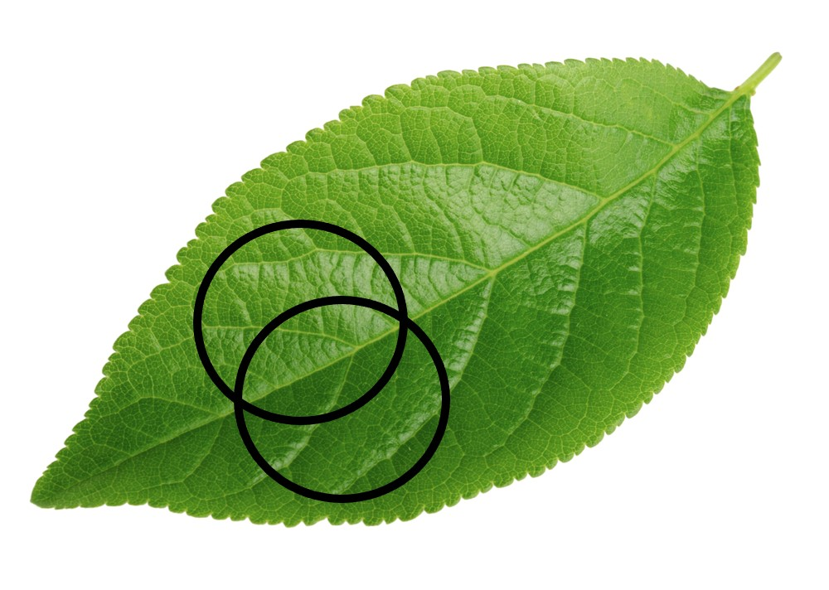

### 3. Measure

* After clamping, "search stability" should appear immediately on top of the screen. If not, open the chamber and reclamp.
* After several seconds, It will read automatically, and be accompanied by red light and sound prompts. Then open the chamber.
* Prompt (right button) and choose the one of notes (lower/upper/wrong), and use the circular button to confirm.
  + Select “wrong” if you will re-do
* On the info (data screen), use the circular button to start the next measurement

### 4. Mark leaf with zip tie (early season only)

* Loosely mark the focal leaf with a zip tie for leaf trait measurements

## Save data

* Connect the Porometer to the computer and make sure it is open.
* Connection Overview-LI-600
* Download data.
  + After downloading, it will ask to clean the data in the instrument, and select “clean”

## Paper record

* Use paper notes record to the measurement. For example, the reasons for no measurement.
  + Died/D: individuals have died
  + Empty/EM: the position is empty
  + Small/SM: Too small to measure
  + Other: Other reasons cannot be measured, for example, wet, can also be indicated.
* After completing the measurement of one row, write the signature and the date.